**LAB-6**

Muhammad Bilal

021-18-0037

1. Write a query in SQL to display details of those employees who have changed jobs at least once. (Sample tables: employees & job_history)
2. Write a query to find the name (first_name, last_name) and the salary of the employees who have a higher salary than the employee whose last_name='Bull'. (Sample tables: employees)

SELECT FIRST_NAME, LAST_NAME, SALARY FROM employees WHERE SALARY > (SELECT salary FROM employees WHERE last_name = 'Bull'); 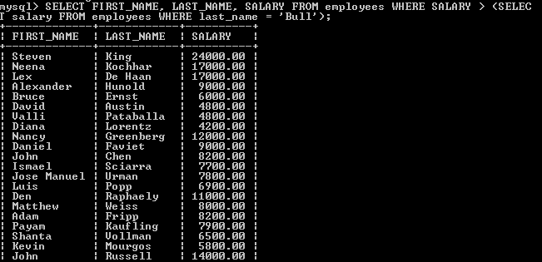

1. Write a query to find the name (first_name, last_name) of all employees who works in the IT department. (Sample tables: employees)

SELECT first_name, last_name FROM employees WHERE department_id IN (SELECT department_id FROM departments WHERE department_name='IT'); 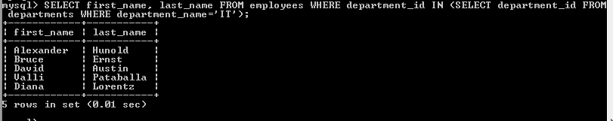

1. Write a query to find the name (first_name, last_name) of the employees who have a manager and worked in a USA based department. (Sample tables: employees, departments & locations)

SELECT first_name, last_name FROM employees WHERE manager_id in (select employee_id FROM employees WHERE department_id IN (SELECT department_id FROM departments WHERE location_id IN (select location_id from locations where country_id='US')));

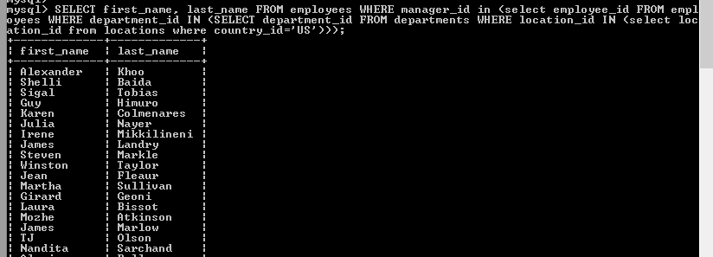

1. Write a query to find the name (first_name, last_name) of the employees who are managers. (Sample tables: employees)

SELECT first_name, last_name FROM employees WHERE (employee_id IN (SELECT manager_id FROM employees)); 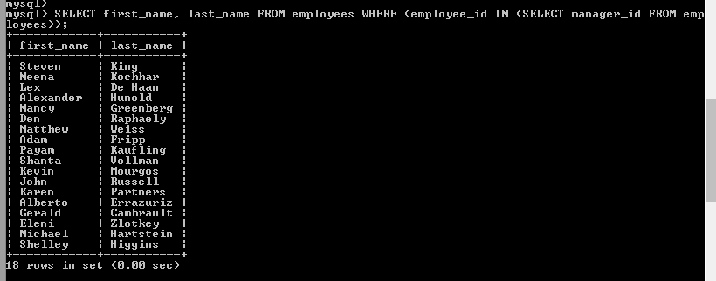

1. Write a query to find the name (first_name, last_name), and salary of the employees whose salary is greater than the average salary. (Sample tables: employees)

SELECT first_name, last_name, salary FROM employees WHERE salary > (SELECT AVG(salary) FROM employees); 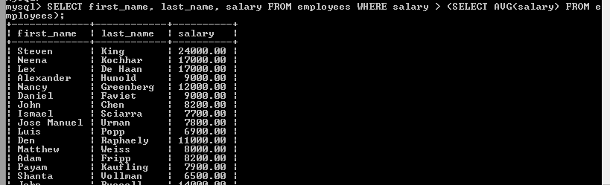

1. Write a query to find the name (first_name, last_name), and salary of the employees whose salary is equal to the minimum salary for their job grade. (Sample tables: employees & jobs)

SELECT first_name, last_name, salary FROM employees WHERE employees.salary = (SELECT min_salary FROM jobs WHERE employees.job_id = jobs.job_id); 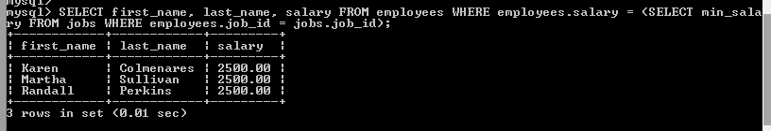

1. Write a query to find the name (first_name, last_name), and salary of the employees who earns more than the average salary and works in any of the IT departments. (Sample tables: employees & departments)

SELECT first_name, last_name, salary FROM employees WHERE department_id IN (SELECT department_id FROM departments WHERE department_name LIKE 'IT%') AND salary > (SELECT avg(salary) FROM employees); 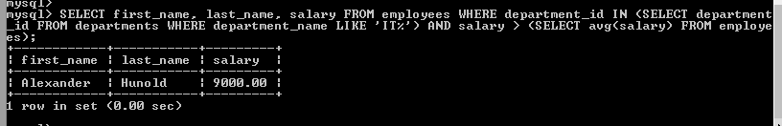

1. Write a query to find the name (first_name, last_name), and salary of the employees who earns more than the earning of Mr. Bell. (Sample tables: employees & departments)

SELECT first_name, last_name, salary FROM employees WHERE salary > (SELECT salary FROM employees WHERE last_name = 'Bell') ORDER BY first_name;

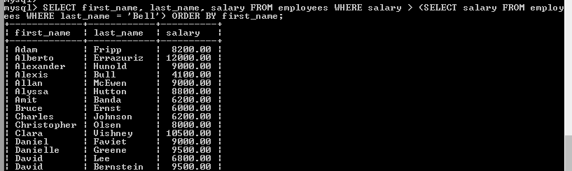

1. Write a query to find the name (first_name, last_name), and salary of the employees who earn the same salary as the minimum salary for all departments. (Sample tables: employees & departments)
2. Write a query to find the name (first_name, last_name), and salary of the employees whose salary is greater than the average salary of all departments. (Sample tables: employees)

SELECT * FROM employees WHERE salary > ALL(SELECT avg(salary)FROM employees GROUP BY department_id);

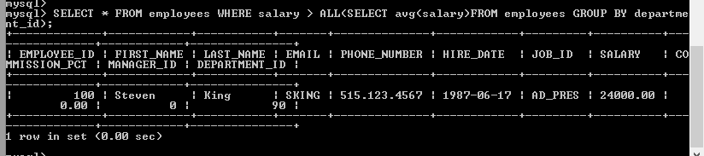

1. Write a query to find the name (first_name, last_name) and salary of the employees who earn a salary that is higher than the salary of all the Shipping Clerk (JOB_ID = 'SH_CLERK'). Sort the results of the salary of the lowest to highest. . (Sample tables: employees)

SELECT first_name,last_name, job_id, salary FROM employees WHERE salary > ALL (SELECT salary FROM employees WHERE job_id = 'SH_CLERK') ORDER BY salary; 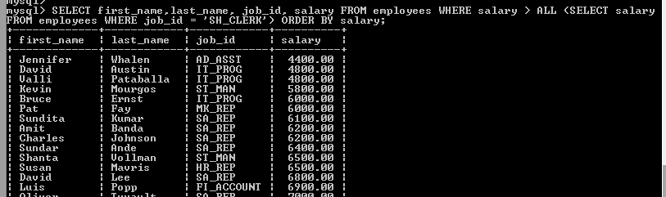

1. Write a query to find the name (first_name, last_name) of the employees who are not supervisors. (Sample tables: employees)

SELECT b.first_name,b.last_name FROM employees b WHERE NOT EXISTS (SELECT 'X' FROM employees a WHERE a.manager_id = b.employee_id); 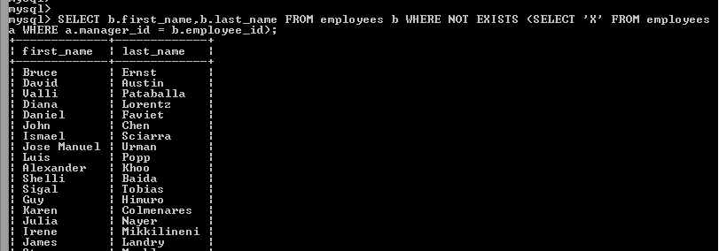

1. Write a query to display the employee ID, first name, last name, and department names of all employees. (Sample tables: employees & departments)

SELECT employee_id, first_name, last_name, (SELECT department_name FROM departments d WHERE e.department_id = d.department_id) department FROM employees e ORDER BY department;

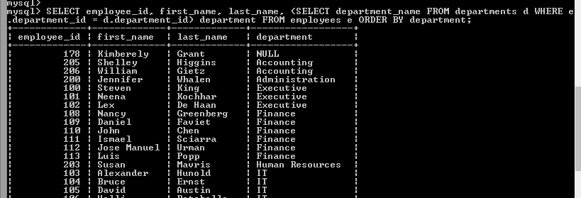

1. Write a query to display the employee ID, first name, last name, salary of all employees whose salary is above average for their departments. (Sample tables: employees & departments)

SELECT employee_id, first_name FROM employees AS A WHERE salary > (SELECT AVG(salary) FROM employees WHERE department_id = A.department_id); 